**User Manual:**

**Objective:**

As a player, your goal is to figure out the pattern of the cards that the art dealer is interested in. The deck consists of standard playing cards, and the dealer will always have a hidden pattern. You need to guess what the pattern is based on the cards presented.

How to Run the code:

* Download .py file.
* Open it in VS Code
* Open New terminal
* Make sure you are in right directory
* Write this command: python game.py
* And Game will start.

**Gameplay:**

**Start the Game:** Once you run the program, a graphical interface (Tkinter window) will appear with shuffled cards from a deck.

**Pattern Guessing:** The dealer will present a few cards, and you have to figure out the pattern. Patterns include:

**All Prime Numbers**: Cards that represent prime numbers (e.g., 2, 3, 5, 7).

**Cards Sum to 9**: The values of all cards add up to 9.

**Ace and Black Jack**: A combination of an Ace and a black Jack (either spades or clubs).

**All Even Numbers**: All cards presented are even numbers.

**All Face Cards**: All cards are face cards (Jack, Queen, King).

**Hints:** If you're stuck, the game provides hints for each pattern:

Prime numbers: "Check if the numbers are prime!"

Sum to 9: "Maybe the numbers add up to something."

Ace and a black Jack: "Look for an Ace and a black card."

Even numbers: "Are all the numbers divisible by 2?"

Face cards: "Are all the cards’ people (J, Q, K)?"

**Guessing the Pattern:** Use the available clues and hints to make a guess about the pattern. The dealer will let you know if you are correct or incorrect.

**Game Over/Restart:** If you successfully guess the pattern, you win the round. You can choose to start a new game or exit.

**User Interface (UI) Overview**

**Main Game Window:**

**Deck Display:** Shows the shuffled cards dealt by the dealer.

**Hint Button:** Provides hints to help you guess the pattern.

**Guess Button:** After selecting the cards you believe fit the pattern, click this to submit your guess.

**Message Box:** Alerts you whether your guess was correct or incorrect.

**Hints:**

Hints will appear in a message box when you click on the 'Hint' button. Use these to deduce the hidden pattern.

**Patterns in the Game**

The dealer's patterns are randomly selected from the following:

**All Prime Numbers:** Cards where the numbers are prime.

**Cards Sum to 9:** Cards that sum up to exactly 9.

**Ace and a Black Jack:** A combination of Ace and Jack (either in the spades or clubs suit).

**All Even Numbers:** Cards where all numbers are even.

**All Face Cards:** Cards that are all face cards (Jack, Queen, King).

**Game Play:**

**Play Game**

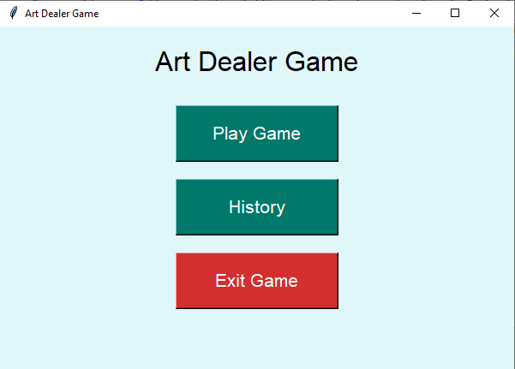

**Pick Cards:**

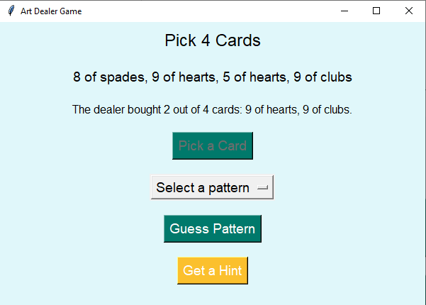

**Select Pattern:**

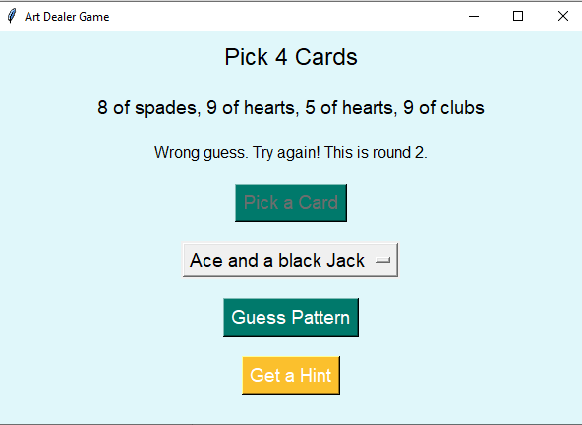

It gets wrong.

Select pattern again, user has total 3 tries:

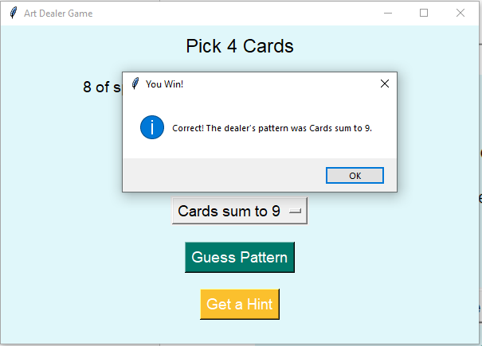

Now it gets right.

**Celebration:**

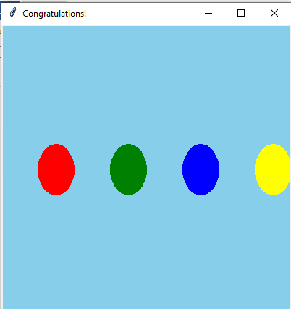

**Get Hint:**

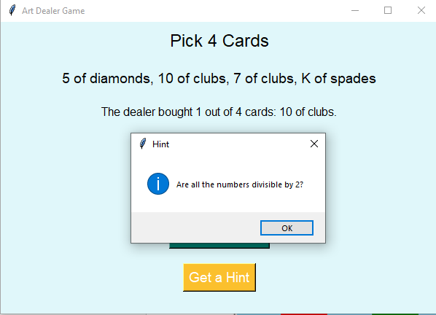

**Reset Game:**

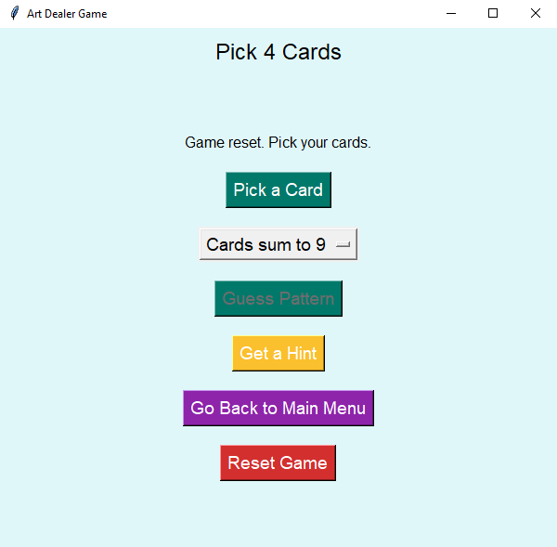

**History:**

